How can anyone be against wind power?!
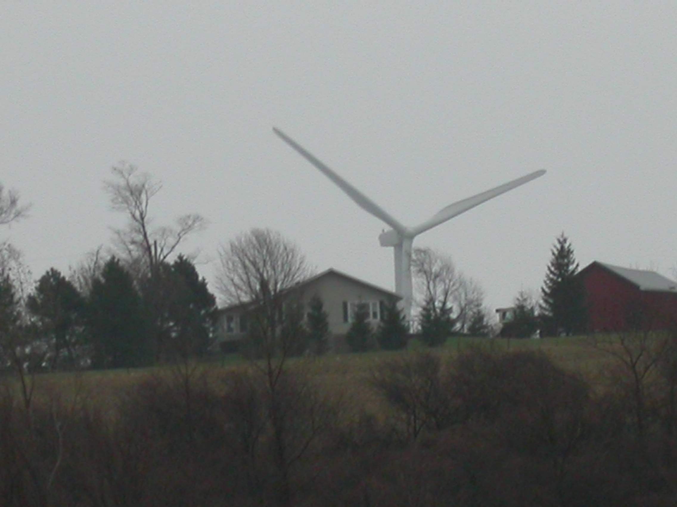

You’d be hard pressed to find many that are simply against wind power, but there ARE hundreds of environmental groups around the world that DO oppose commercial wind development, and are working hard to bring awareness to the many controversial issues associated with it.

Commercial wind is not cheap and it’s not green. The industry’s fantastically giant industrial wind turbines create enormous impacts on our natural and wild places and on communities where people live. But the benefit of even a thousand turbines is miniscule and does little to address today’s energy or air quality problems, in spite of the industry’s misleading claims that would have you believe otherwise. AND for every wind “farm” that gets built in N.Y. State, our electric bills go up!

The wind industry, in its present form, has created a new kind of pollution. It’s mere green tokenism and an environmental and economic folly that’s wasting precious time and resources, and is steering us away from finding true solutions to the energy and global warming dilemmas.

For more information, contact the Sardinia Preservation Group at 716-592-1403 or log on to www.savesardinia.com

