1) Kavelstorf Windfarm – One of two investments in Germany
http://www.catenergy.com/projects/kavelstorf_windfarm.html

Kavelstorf Windfarm
The Kavelstorf Windfarm (DK Windpark Kavelstorf GmbH & Co. KG) is an indirect wholly owned subsidiary of CIC Luxembourg SaRL. The Project, along with the Eckolstädt Windfarm, represents Catamount's first investment with the partners of the Catamount Investment Company, an equity investment fund managed by Catamount.
The Project consists of four model Nordex N-60 1.3 MW wind turbines and two model Nordex N-54 1.0 MW wind turbines. The six WTG's are expected to generate approximately 13 gigawatt-hours, enough electricity to power over 4,000 homes with a clean and reliable source of energy.
The Project was developed by enXco GmbH and acquired by CIC in November 2000. The Project is located in Mecklenburg-Vorpommern, in the District of Bad Doberan, in the municipality of Kavelstorf, in the Federal Republic of Germany. The Project is situated on level agricultural land located in the vicinity of Rostock, approximately 10 km from the Baltic Sea. The 1.3 MW and 1.0 MW wind turbines have hub heights of 69 and 60 meters respectively. All of the wind turbines are equipped with three rotor blades. Rotor diameters are 60 and 54 meters for the 1.3 MW and 1.0 MW units respectively.
The Project began operation in April 2001 and is selling generated electricity to the regional electricity supply utility, E.D.S. Energie Nord AG ("e.dis"), under the 2000 Renewable Energy Sources Act.

KAVELSTORF WINDFARM
Mecklenburg-Vorpommern, Germany

Project Participants

Owners: DK Bürgerwindpark Eckolstädt
GmbH & Co. KG
General Partner: CIC Verwaltungs GmbH
Limited Partner: CIC Luxembourg SaRL
Equity Investors: Catamount Energy Corp.
The CIT Group
Dana Commercial Credit Corp

Project Characteristics

Electrical Capacity: 7.2 MW
Electrical Production: 13 GWh
Power Purchaser: e.dis
Turbine Supplier: Nordex GmbH
Project Cost: 8.7 Million
Financing: 6.9 Million
Lender: Commerzbank AG
Administration: enXco GmbH
Maintenance: Nordex GmbH
Management: Catamount Energy Corp.

1a) Second windfarm Catamount has invested in in Germany
http://www.catenergy.com/projects/eckolstadt_windfarm.html
Eckolstädt Wind Farm
The Eckolstädt Windfarm (DK Bürgerwindpark Eckolstädt GmbH & Co. KG) is an indirect wholly owned subsidiary of CIC Luxembourg SaRL. The Project, along with the Kavelstorf Windfarm, represents Catamount's first investment with the partners of the Catamount Investment Company, an equity investment fund managed by Catamount.
The Project is currently 13.0 MW and consists of ten Bonus 1.3 MW wind turbine generators (WTG's) with an eleventh unit currently in the planning stages. The eleven WTG's are expected to generate approximately 26 gigawatt-hours, enough electricity to power over 7,000 homes with a clean and reliable source of energy.
The Project was developed by enXco GmbH and acquired by CIC in November 2000. The Project is located in Thüringen, in the state of Weimar, in the Federal Republic of Germany. The windpark is approximately 300 meters above sea level and is situated between Bornstädt and Eckolstädt, and a part of the park is located on former military land. All wind turbines have a hub height of 68 meters, are equipped with three rotor blades, and have a rotor diameter of 62 meters.
The Project and nine of its wind turbines have been in operation and on the grid since January 2000 and have sold generated electricity to the regional electricity supply utility, Thüringer Energie, AG ("TEAG"), under the 2000 Renewable Energy Sources Act.

Eckolstädt Wind Farm
Thüringen, Germany

Project Participants

Owners: DK Bürgerwindpark Eckolstädt
GmbH & Co. KG
General Partner: CIC Verwaltungs GmbH
Limited Partner: CIC Luxembourg SaRL
Equity Investors: Catamount Energy Corp.
The CIT Group
Dana Commercial Credit Corp

Project Characteristics

Electrical Capacity: 14.3 MW
Electrical Production: 26 GWh
Power Purchaser: TEAG
Turbine Producer: Bonus Energy A/S
Turbine Supplier: AN Windenergie GmbH
Lender: Sparkasse Bremen
Administration: enXco GmbH
Maintenance: AN Windenergie GmbH
Management: Catamount Energy Corp.

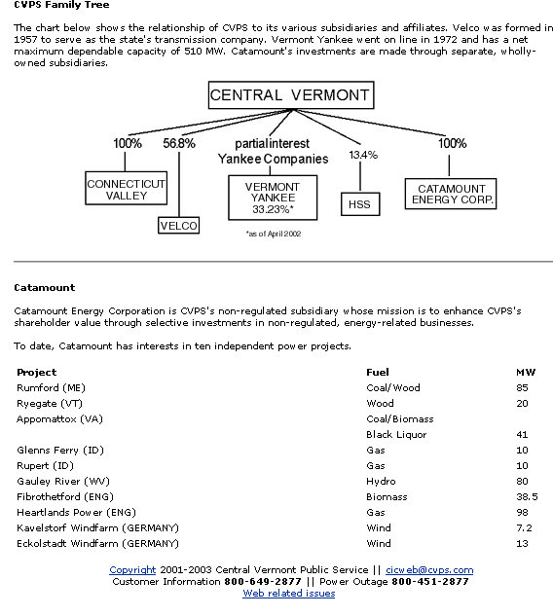

1b) www.cvps.com/about/quickfacts.shtml

http://www.catenergy.com/dev_projects/glebe_mtn.html 3-5-03

